**ADK (Python Programming) ROLL NO : 01**

**Aim**: Write the program for the following: (by using control statements and control structure)

### (E). Write a function to check the input value is Armstrong and also write the function for palindrome.

**Theory: -**

**Practical Implementation:-**

# Python program to check if the number provided by the user is an Armstrong number or not

def armstrong(num):

num=0

# find the sum of the cube of each digit

temp=num

while temp>0:

digit=temp%10

sum+=digit**3

temp//=10

# display the result

if num == sum:

print(num,"is an armstrong number")

else:

print("is not an armstrong number")

def palindrome(num):

n=num

rev=0

while num !=0:

rev=rev *10

rev=rev +int(num%10)

num=int(num/10)

if n== rev:

print(n,"is pelindrome number")

else:

print(n,"is not palin")

# take input from the user

num=int(input("enter a nummber to check it is armstrong or not:"))

armstrong(num)

# take input from the user

num=int(input("enter a number to check it is palindrome or not:"))

palindrome(num)

**output:-**

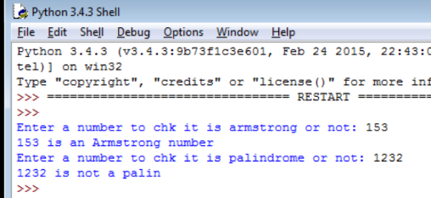

**Conclusion:**